2. Explanation of Source Code

TASK DESCRIPTION
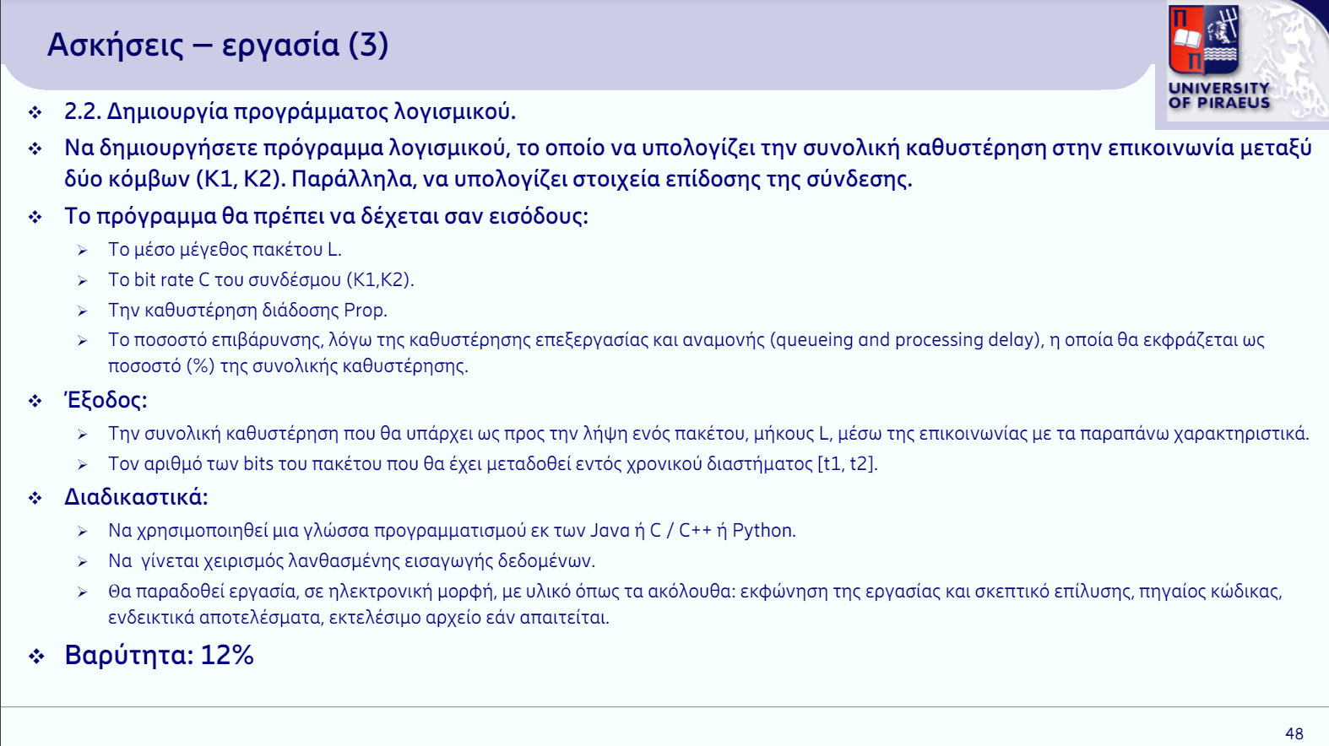
- Solution Rationale
The program first asks for the average size of the packet L. A validity check is performed for the value entered by the user. L must be greater than or equal to zero. If it is not, it displays an error message to the user. The same happens with the input of the Rate bit C (must C>0), the propagation delay Prop (must Prop>=0 ) and the delay rate (must be in the range [0,100]). In addition, try... except is used in each input. Thus, it is checked whether the user enters a value that would result in an error (e.g., the user enters in the Rate C bit instead of float, string).

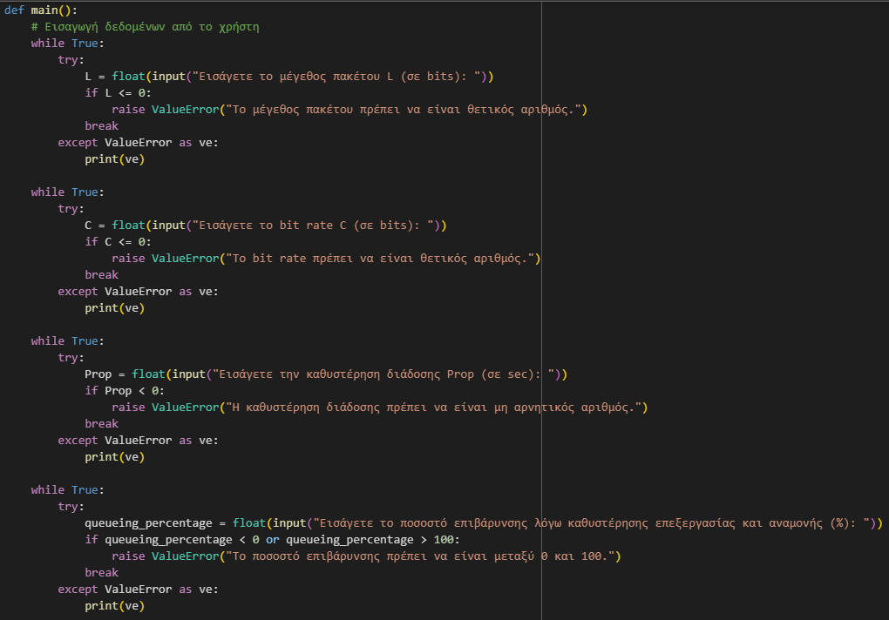
After entering these values, we can calculate the delay. To calculate it, I create a method, calculate_delay, which I call. This method contains the formula for finding the delay (Prop + (L/C)*1000) and the formula for finding the delay with the percentage of overhead (total_delay*(1 + queuing_percentage/100 )). Then total_delay_with_queueing is displayed to the user.
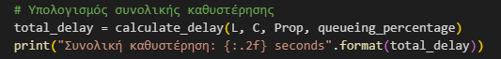
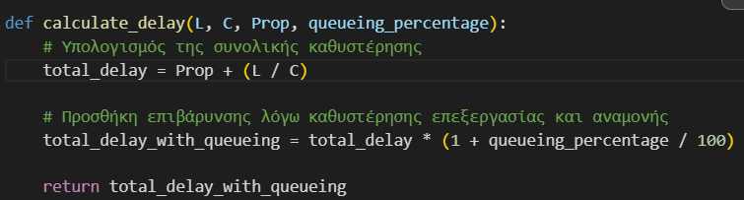

The program then asks for the input of the time when the user wants to see the number of bits of the packet transmitted. As a validity check, we need t2>t1. As in the previous inputs, try is used to avoid errors on the part of the user. After the insertion of t1 and t2 is complete, the number of bits transmitted is calculated by a new method, calculate_transmitted_bits, which is called. After the value has been calculated, it is displayed on the user's screen.
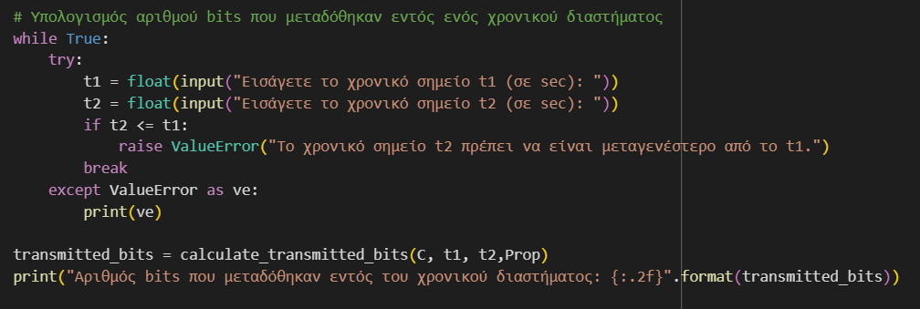
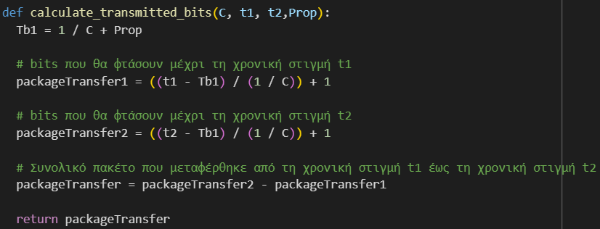

Sample Solution
Input packet size L, bit rate C, Prop and overhead rate:
eg1:
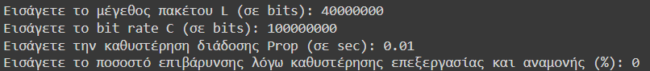
eg2:
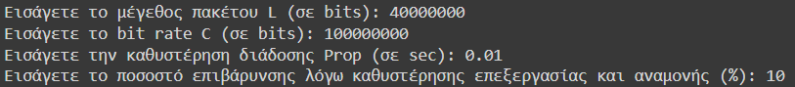

Eg3:
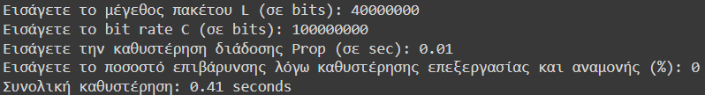
eg4:
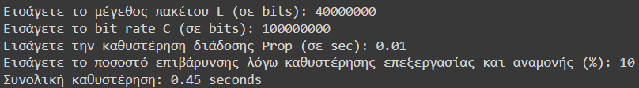
Insert t1, t2:
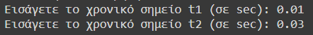
Result:
